SUMMER INTERNSHIP
APPLICATION

FOLLOW THE STEPS

❑ Complete the entire application and turn in by March 1
❑ Make a 1-minute video telling us why you want to intern (upload to Dropbox, Drive, etc)
❑ Send completed application, cover letter, resume, photo/video to: queenschurchnyc@gmail.com
❑ Be mindful of the application deadline. Late applications may not be considered.

Summer Internships are applying to serve alongside Connection Church and Queens Church and provides a great opportunity to get on-the-ground training, experience in church planting, community ministry and leading others in New York City. Interns, with the support and guidance of the Connection/Queens Church Staff, raise their own support ($4,000) that will cover all necessities (flights, transportation, housing, meals, entertainment, etc…) and will serve from late May-Early August (dates are flexible). All applicants must be 18 years of age or older.

Applications are received and Interns are accepted without regard to race, creed, color, sex, age, national origin, marital status, physical or mental handicap, veterans status and citizenship status. The receipt of this application does not mean that an Intern position is available nor does it obligate us in any way. We appreciate your interest in our organization. Please submit this completed application with a cover letter explaining why you would like to serve in your chosen area of ministry along with a resume. While completing this application if you find it necessary to provide additional comments or explanations to questions asked, please include. PLEASE PRINT OR TYPE ALL INFORMATION!

Date Prepared ______________ Applying for (Summer) _______________

PERSONAL INFORMATION

Name _________________________________________________________________________________________________ First Middle Last

Current Address _________________________________________________________________________________________________ Street City State Zip Code

Permanent Address _________________________________________________________________________________________________ Street City State Zip Code

Home Phone _______________________ Cell Phone ________________________

Email____________________________________

Gender ____________ Age __________ Date of Birth ______________________ Birthplace (City, State) ______________________

Marital Status _______________ If Married, Spouse’s Name and date of Marriage_______________________________

Name and Ages of Children (If Applicable) ___________________________________________________________________________

Are you a citizen of the United States? _____

What languages can you read, speak and write fluently? __________________________

Emergency Contact Name ___________________________ Relationship _____________________

Emergency Contact Number_____________________

Have you ever been convicted of any crime other than a minor traffic violation? If yes, please explain.
_________________________________________________________________________________________________
_________________________________________________________________________________________________

Have you ever applied for an internship or been employed by Connection Church or Queens Church? If yes, list position. __________________________________________

What do you like to do for fun?_________________________________________________________________________________________________
_________________________________________________________________________________________________

Use six words to describe yourself:
_________________________________________________________________________________________________

Why do you want to be a part of our Summer Internship Program:
_________________________________________________________________________________________________
_________________________________________________________________________________________________
_________________________________________________________________________________________________
_________________________________________________________________________________________________
_________________________________________________________________________________________________
_________________________________________________________________________________________________

Read Philippians 2. What are 3 things that stick out to you most in that passage?
_________________________________________________________________________________________________
_________________________________________________________________________________________________
_________________________________________________________________________________________________
_________________________________________________________________________________________________

What practical things are you doing in your personal relationship with God?
(Please be more specific than “Read my Bible…”)
_________________________________________________________________________________________________
_________________________________________________________________________________________________
_________________________________________________________________________________________________
_________________________________________________________________________________________________

How would being a part of a Summer Internship Team and serving in Queens, NYC help you spiritually, emotionally, and physically?
_________________________________________________________________________________________________
_________________________________________________________________________________________________
_________________________________________________________________________________________________
_________________________________________________________________________________________________

What’s your favorite drink at a coffee shop?
_________________________________________________________________________________________________

Twitter Handle: ____________________ Instagram:______________________ Facebook: ________________________

CHURCH AFFILIATION

Name of home church _____________________________________ Denomination ____________________________
Location (City, State) _______________________________________Number ________________________________

How long have you been a member of this church? ______________
Name of Senior/Lead Pastor __________________________
In what capacity are you currently volunteering? _______________________________________________________________________
Name of person you currently serve under _______________________________________________________________________

Briefly explain when and how you became a Christ Follower __________________________________________________________________________________________________________________________________________________________________________________________________________________________________________________________________________________________________________________________________________________________________________________________________________________________________________________________________________________________________________________________________________________________________________________________________________________________________________________________________________________________________________________________________________________________________________________________________________________________________________________________________________________________________________________________________________________________________________________________________________

Name of High School Attended ____________________________________________________________________________________
Graduation Date _____________________ Location__________________________________________
(City,State)________________________________________________________

List colleges, universities, or other schools you have attended:
Name __________________________________________________ Location (City, State)________________________
Dates Attended __________________________________________
Diploma/Degree ______________________________________

Name __________________________________________________ Location (City, State)________________________
Dates Attended __________________________________________
Diploma/Degree ______________________________________

Name __________________________________________________ Location (City, State)________________________
Dates Attended __________________________________________
Diploma/Degree _________________________________________

Current Employer _________________________________________
Current Position_______________________________________
Date Hired ___________________________ Responsibilities ____________________________________________
Name of Immediate Supervisor______________________________ Number _______________________________

Previous Employer _______________________________________ Position___________________________________
Dates of Employment ____________________ Responsibilities ____________________________________________ Name of Immediate Supervisor _____________________________ Number _________________________________

Previous Employer _______________________________________ Position___________________________________
Dates of Employment ____________________ Responsibilities ____________________________________________ Name of Immediate Supervisor _____________________________ Number _________________________________

PERSONAL REFERENCES

Name _______________________________________ Position_____________________________________________
Number ____________________________ Email ________________________________________________________

Name _______________________________________ Position_____________________________________________
Number ____________________________ Email ________________________________________________________

Name _______________________________________ Position_____________________________________________
Number ____________________________ Email ________________________________________________________

APPLICANT’S STATEMENT – READ CAREFULLY!

The information I have given is correct and may be verified by Connection Church and Queens Church if necessary. I understand that if I am admitted to the Internship Program, Connection Church and Queens Church reserves the right to disqualify me from the Internship Program for any reason it deems appropriate. I hereby release and hold Connection Church and Queens Church harmless from all claims arising under this application. I further understand that a criminal record check may be conducted on me and I consent to any such check.

_____________________________________________________ _____________________________
Signature Date

If you have any further questions about the Summer Internship Program, please do not hesitate to contact us!

Danny Rangel
Lead Coordinator of Summer Internship Program
Co-Planter of Queens Church

Phone: 956-802-3452
Email: queenschurchnyc@gmail.com

Larry Mayberry
Lead Pastor of Queens Church

Phone: 713-494-9242
Email: queenschurchnyc@gmail.com

Daniel McGhee
Lead Pastor of Connection Church

Phone: 347-407-2105
Email: daniel@connectionnyc.com

Follow us on Instagram:

@connectionnyc

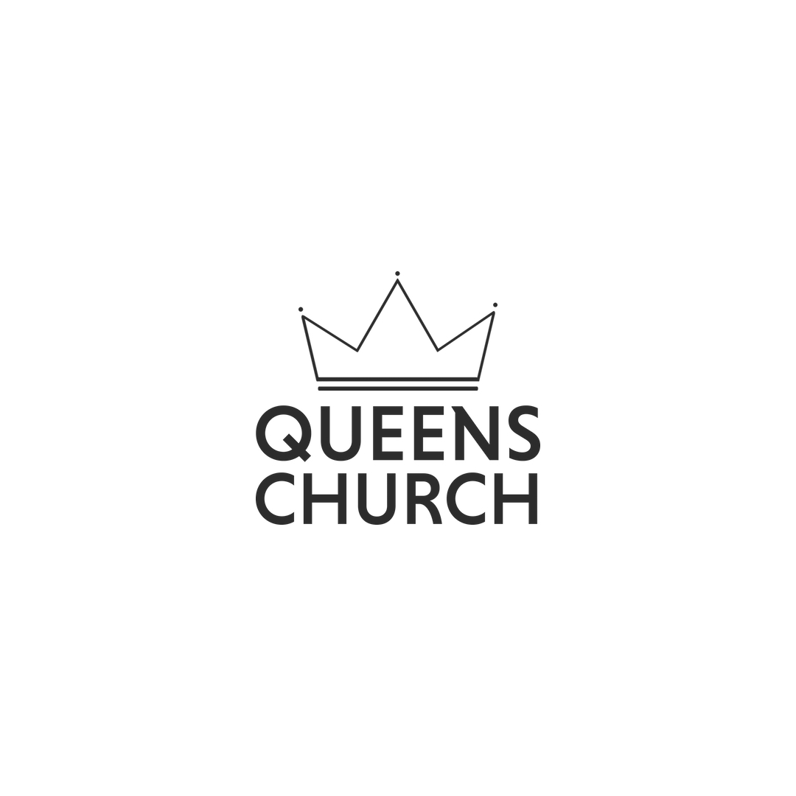
@queenschurchnyc

